# 

# 

Thanks for volunteering, we have put together this handbook to help you get started. There are several thing you will need to do prior to you first practice and game. We have tried to make it easy by putting this step by step guide together. If you get lost you can always email one of the Board of Directors.

* TABLE OF CONTENTS
  + Board of Directors (BOD)
  + Background check & CDC Training
  + SafeSport Certification
  + Players Pass
  + Roster
  + Medical Release
  + Parent meeting draft
  + Practice info
  + Helpful information

Below is a list of the Board of Directors emails and phone numbers, in case you need to ask a question.

|  |  |  |  |
| --- | --- | --- | --- |
| **Position** | **Name** | **Email** | **Cell Number** |
| ***President*** | Jay Denison | [President@aiysoccer.com](mailto:President@aiysoccer.com) | (904) 206-2390 |
| ***Vice President*** |  |  |  |
| ***Secretary*** |  |  |  |
| ***Treasurer*** | Stacy Hanna | [Treasurer@aiysoccer.com](mailto:Treasurer@aiysoccer.com) |  |
| ***Registrar*** | Jay Denison | [Registrar@aiysoccer.com](mailto:Registrar@aiysoccer.com) |  |
| ***Director of Advanced Competition*** | Jay Denison | [President@aiysoccer.com](mailto:President@aiysoccer.com) | (904) 206-2390 |
| ***Director of Recreational*** | Aaron Opheim | [DirofRecreational@aiysoccer.com](mailto:DirofRecreational@aiysoccer.com) | (904) 415-9065 |
| ***Director of Referees*** | Mike Giannini | [Assignor@aiysoccer.com](mailto:Assignor@aiysoccer.com) |  |
| ***Director of Public Relations*** | Shelly Domingo | [Public_Relations@aiysoccer.com](mailto:Public_Relations@aiysoccer.com) |  |
| ***Director of Coaching*** | Andy Francis | [Dir_of_Coaching@aiysoccer.com](mailto:Dir_of_Coaching@aiysoccer.com) |  |
| ***Director of Volunteers*** |  |  |  |
| ***Director of Fund Raising*** | Dave Mumbauer | Dirfundraising[@aiysoccer.com](mailto:Volunteers@aiysoccer.com) |  |

This hand book was put together to help new coaches navigate their way through the admin side of coaching for AIYS. It is extremely important that you complete the following before the start of your first practice each year.

1. Do your background check in gotsoccer
2. Complete the center for disease control (CDC) test
3. Complete the SafeSport certification

Once you have been selected as a coach for AIYS you will receive an email with a user ID and password to gostsoccer. Follow these direction to complete all three requirements.

Step 1: Login to Gotsoccer.com <https://home.gotsoccer.com/>

Step 2: Click the login button in the right corner

Step 3: Under member Account click: Teams & Team Officials Login

Put in the Username and Password provide to you in an email for individual coach or manager and click Login. If you do not have one contact the Registrar and request one.

Background check: click here. <https://www.gotsport.com/asp/users/login_menu.asp?tab=member>

Center for Disease Control and SafeSport, Direction for Safesport [Click here](https://gotsoccer.zendesk.com/hc/en-us/articles/360016124433-SafeSport-Certification-Instructions-)

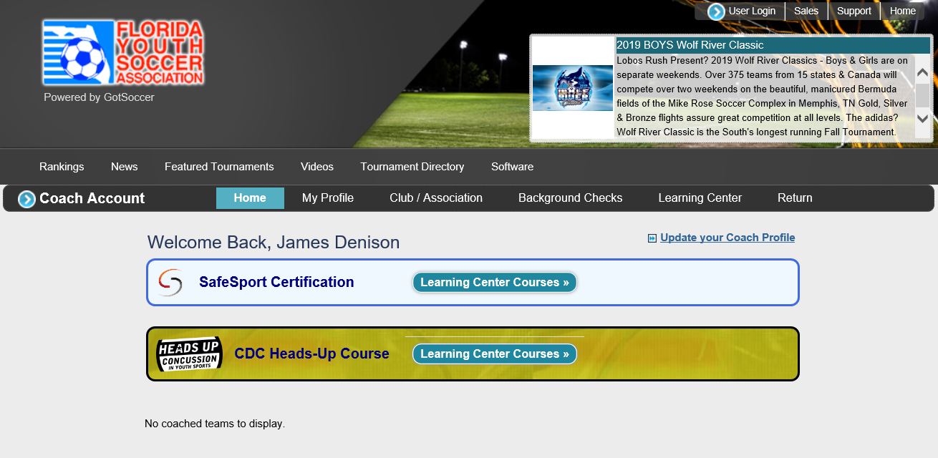

All coach (Head/Assistant coach) and managers are requirements to have background check, CDC and Safesport *completed* Pryor to getting roster of players and or starting your first practice! **U6-U10 coaches:** You are done with the certification in gotsoccer you can skip to page 8, Certification and training .

**\*\*U11 and up coaches need the following:** Because you will be playing team from other clubs.

1. Player passes (laminated)
2. Roster
3. Medical release forms(signed by parents)

**Player passes:**

You can share this with the team manager and parents so that they can load the head shots

Step 1: Visit www.gotsoccer.com and then

Step 2: Click on “User Login” in the top right corner of the page.

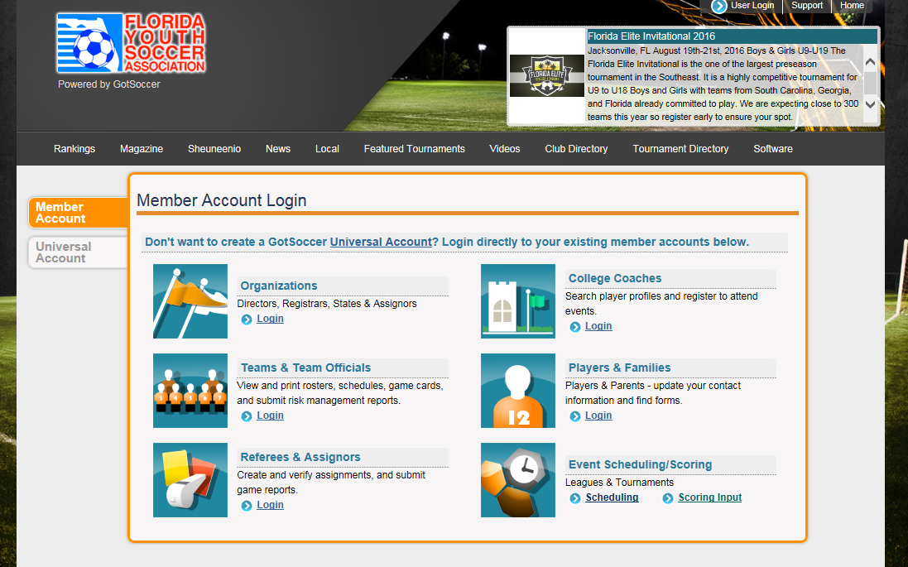

Step 3: Choose “Players & Families” then enter your Username and Password. Use your **PLAYER** login and password that has been provided to you by email from GotSoccer. If you don’t remember it ask registrar.

Step 4: Choose “Get Started”

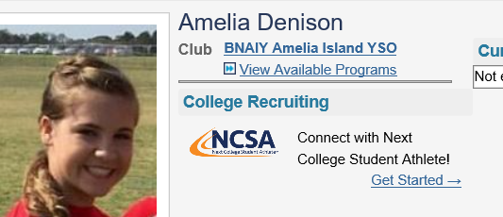

Step 5: Choose Player Tab and make sure information is correct and add a head shot.

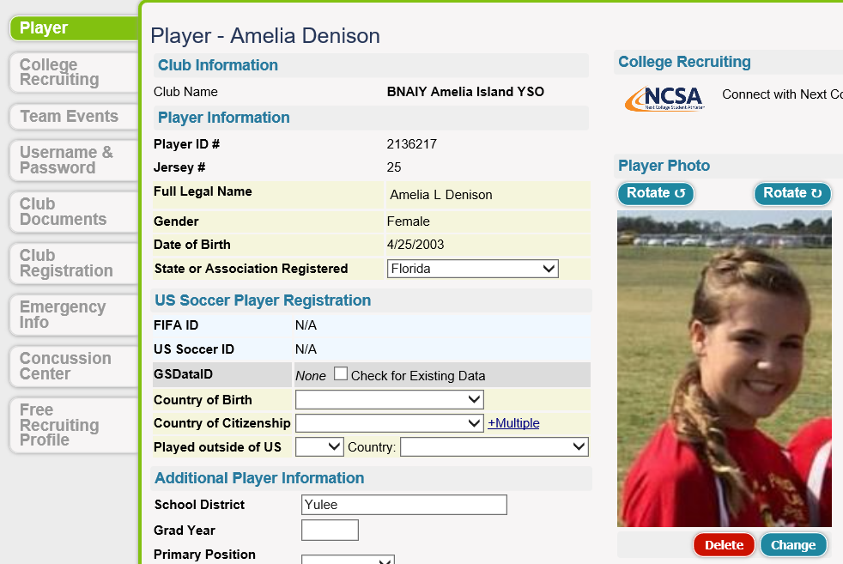

The roster will be generated by the registrar once you have all of your player with correct head shots. Each parent is responsible for uploading the head shot of his son or daughter in gotsoccer.

You will need to remind your parents at the first practice or parent meeting to go home and upload a head shot. Please make sure that the picture you or parent upload is passport style and is no more than 500kb. Larger photos will load, but your passes will not print.

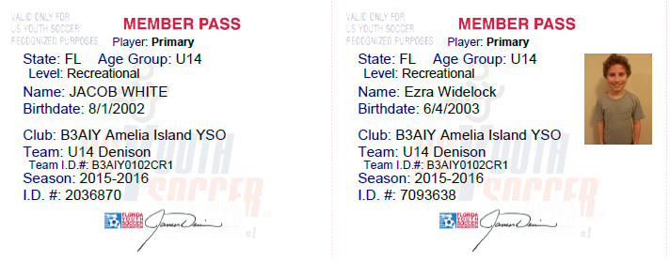

Bad Player ID Cards **missing picture Good Player ID Cards

The player pass on the left is missing the picture and this player is not qualified to play.

** There is a laminator in the concession stand just ask a board member and they will help you find it.

**Rosters:**

Printing Rosters for valid game rosters is also available through GotSoccer.

Step 1: Login to the team account (Make sure you use your team ID and Password)

Step 2: Click on “User Login” in the top right corner of the page.



Step 3: Choose “Team/Team officials” then enter your Username and Password in the “Team Account” login. Use your team login and password that has been provided to you by email from GotSoccer. If you don’t remember it ask registrar.

Step 4: From Home Tab, choose the “Team Profile”

Step 5: Click on the **“Documents”.** If you are unable to view your roster, please contact registrar.

Example of roster

This is the only roster that is authorized to verify player. Do not use the one out of “Blue Sombrero”.

You will need this roster at all games.

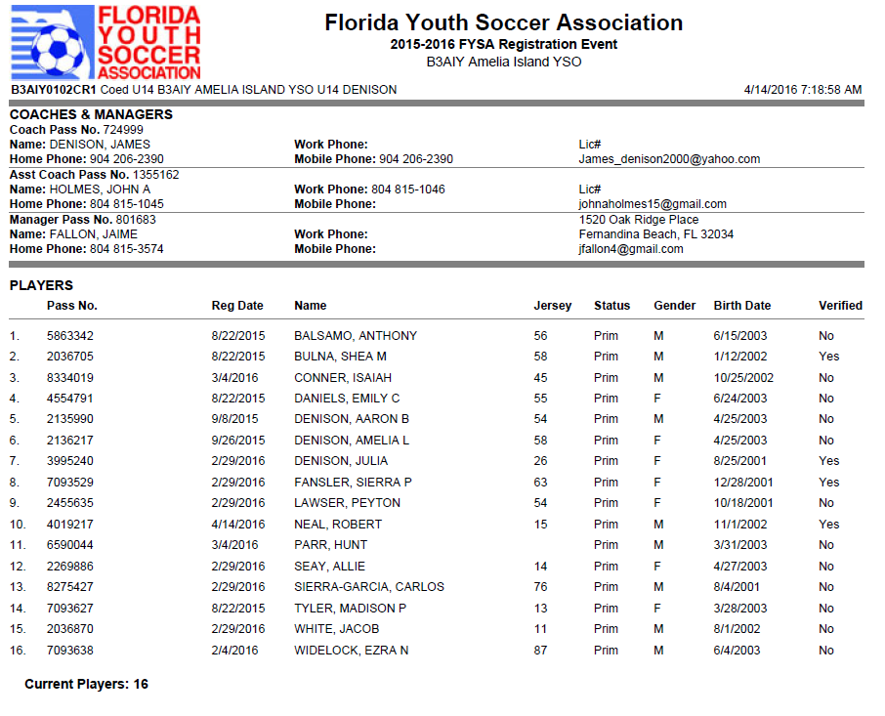

**\*\*\***All U11 and above coaches must have a copy of the “Official roster” and laminated copies of “player passes” at all games, (home and away). The club will be fined if you don’t have both during check-in process prior to game.

**If you do not see your name or your assistant coach's name on the official roster then we do not show you as having completed the background check or CDC Heads up Concussion video. If you have completed them, then please use your individual coach login to look it up and send the administrators at the emails noted above. To log into your coach account (after it has been created), you must log into gotsoccer, team/team officials/individual coach.

**Medical Release form**

Step 1: Visit www.gotsoccer.com and then

Step 2: Click on “User Login” in the top right corner of the page.



Step 3: Choose “Team/Team officials” then enter your Username and Password in the “Team Account” login. Use your **team** login and password that has been provided to you by email from GotSoccer. If you don’t remember it ask registrar.

Step 4: On the top bar next to your team name you will find the “View/Print player medical release forms”. This form needs to be printed out and signed by all parents and taken to all practices and games.

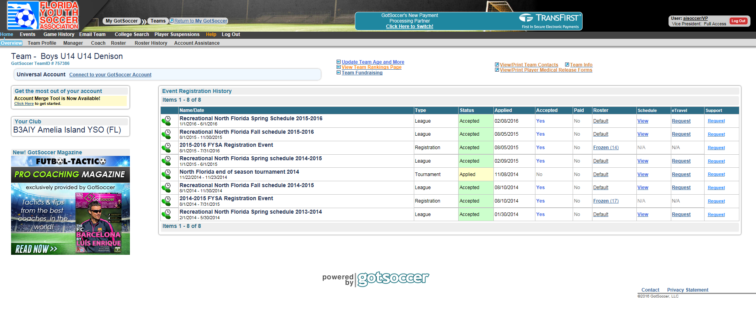

**Practice:**

Coaches should sign up for practices at the coaches meeting or if you didn’t make the coaches meeting contact the Dir of Recreational. If you have any questions about the schedule, please see website or contact Dir of Recreational and or registrar.

Recommended Practice times:

U6 – 30 Minutes — Once per week

U8 – 30 Minutes— Once per week

U10- 45 Minutes—Twice per week

U12- 1 hour —Twice per week

U14- 1.5 hours —Twice per week

Division Technical Practice: This season we will continue to have division technical practice days for teams in U4-U10 divisions.

Mondays **U8**s – two sessions – 5:15PM and 6:15PM

Tuesdays **U10**s – two sessions – 5:15PM and 6:15PM

Wednesdays **U4**s – three sessions – 5:15PM, 5:30PM, and 6:10PM

Thursday **U6**s – two sessions – 5:15PM and 6:15PM

1. We are working to have space for all our teams to practice, however space is tight and there is little room for movement please practice on your designated field and time slot that you picked during the coaches meeting.
2. It is the Coach and team responsibility to put the fields back to the original set up for the next day. For example, if you are a U12 team practicing on the field #10 and use the small goals from U8 #6, please make sure all small goals are set back in proper location for the U8 teams

**Helpful Information**

**Game Day Uniforms:**

Red/Blue = home team

White/Blue = away team

**Game change policy and Reporting Scores (**U11 and up only) [Click Here](https://www.aiysoccer.com/Default.aspx?tabid=660970)

**Volunteer Hours**

All Coaches and Team manager are exempt from volunteer hours. You have done your part already. We do need your help to remind the parents who didn’t buyout about volunteering **3 hours** per player to the club.  They can sign up using **signup genius** on website under parents tab and selecting your desired task and dates. The club tracks who volunteer and who does not and a $20 per hour charge will be added to your next season bill if you do not fulfill your volunteer hours.

**Team Managers**

U6-10, Help the coach out with snack schedule, who is not coming to games and the volunteer duties the parent should be doing. Help with end of season party or any other task you can take off the coach’s plate.

U12 and up: The Team manager should print two copies of player pass and roster. After you have print them take the player passes to the concession building at the fields and laminate them. Give one copy of player passes and roster to the head coach and keep a copy for back up and bring them to all games. Also keep a copy or them medical release and bring to all games. Got Soccer helpful How to for team managers. [Click here](https://gotsoccer.zendesk.com/hc/en-us/articles/360008104854-How-To-Upload-A-Player-Photo-From-A-Team-Account)

**Coaching Certification**

**Digital Coaching Center: Sign up for courses** [**click here**](https://dcc.ussoccer.com/)

**U.S. Soccer coaching education** [**Click here**](http://www.fysa.com/coaches/us-soccer-coaching-licenses/)

U.S. Soccer coaching license Pathway

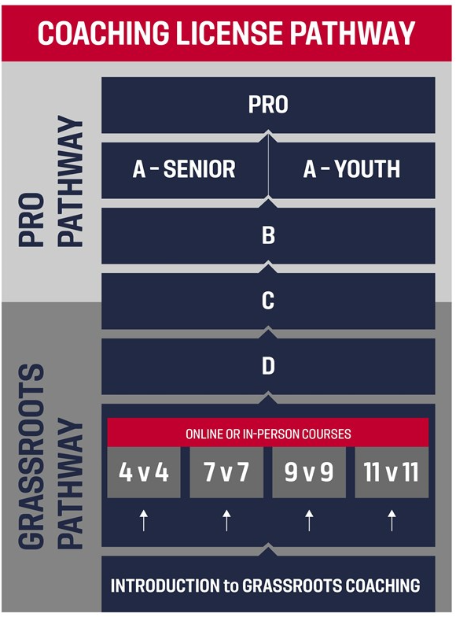

All coaches need to do the online introduction to grassroots coaching. [Click Here](https://dcc.ussoccer.com/courses/available/16/details/1546)

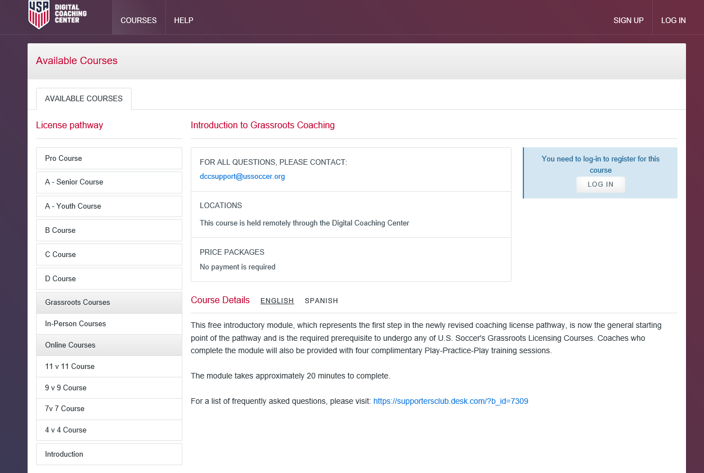

We also recommend that you take the appropriate level course for the team you are coaching.

4v4, 7v7, 9v9 or 11v11

***Email to new coach***.